ANA-050 Analysis Specification
Web-service development
Document Properties
Author | Stéphane Englert
Creation Date | 01.07.2024
Last Updated | 01.07.2024
Document Reference | WS001
Version | V1

Approved By | Position

Content
1 Document Control 3
1.1 Change Record 3
1.2 Reviewers 3
2 General 4
2.1 Objective 4
2.2 Business Process Flows 4
3 Technical Overview 6
3.1 Considerations 6
3.2 Business Rules 6
3.3 INPUT 6
4 Document Validation and Signature 7

Document Control

Change Record
14
Date | Author | Version | Change Reference
 | Stéphane Englert | V1.0 | Initial Version

Reviewers
Name | Position
Denis Boder | Developer
Christophe Pouillot | Project manager

High Level Estimation Proposal
Activity | Hours
ANA-050 Creation and Approval
DES-020 Creation and Approval
Development Time
BC Testing time incl TC transition/discussion
PM Time
Total
Detail Level Estimation Proposal
Activity | Hours
ANA-050 Creation and Approval
DES-020 Creation and Approval
Development Time
BC Testing time incl TC transition/discussion
PM Time
Total

General
The objective of this document is to present all the information required to define a requirement document can also be a reference as a "Functional Architecture Document" and lists all the development requirements for handling this request.

Objective
When we create new configurator, we must enter in PDS051 a large list of machines that are not authorized for specific machines.

This can’t be managed by a manual entry due to the large number of records.
The manual entry task must be replaced by an API or by a Web Service.

The development must contain the CREATE and DELETE transactions.

Business Process Flows

During a configuration entry we currently display only options that are valid for a specific LNS machine.

We decided to work with option PDS051 to avoid user seeing all options defined in PDS056 for a specific feature.

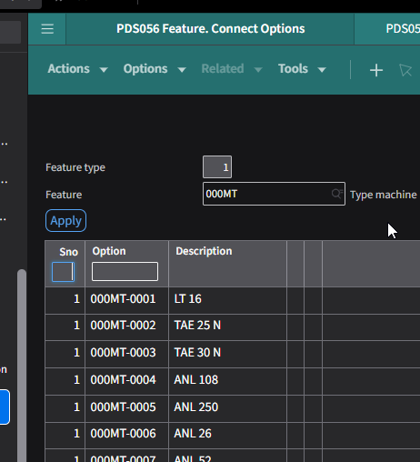

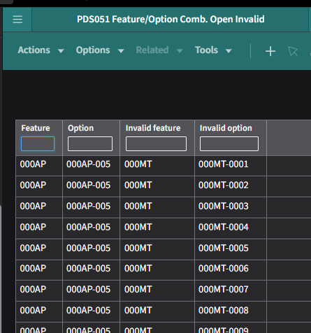

Technical Overview

Considerations
The solution must be accessible from external sofware/tools.

Business Rules
System must perform standard validations:
- Existing company (CONO, mandatory)
- Existing feature (FTID, mandatory)
- Existing option (OPTN, mandatory)
- Existing invalid feature (NFID, mandatory)
- Existing invalid option (NOID, mandatory)

System must return OK message when the transaction went well
Confirmation messages:
- Record created
- Record deleted

System must return KO message when the transaction didn’t go well with explicit error.
Error messages:
- Record already exists (CREATE)
- Record doesn’t exist (DELETE)
- Company doesn’t exist
- Feature doesn't exist
- Option doesn’t exist
- Invalid feature doesn't exist
- Invalid option doesn't exist

INPUT
Input fields

- Company (CONO, mandatory)
- Feature (FTID, mandatory)
- Option (OPTN, mandatory)
- Invalid feature (NFID, mandatory)
- Invalid option (NOID, mandatory)

Document Validation and Signature

 | LNS | Signature
Functional description  Chapters 2,3 | Name: Englert Stéphane
Technical design  Chapter 5 | Name :
Comments

 | INFOR | Signature
Functional description  Chapters 2,3 | Name: ???
Technical design  Chapter 5 | Name:
Comments

